- Install latest PKI Application from the eTender Portal (64bit/32bit) based on your system configuration as highlighted in yellow in the below screenshot.
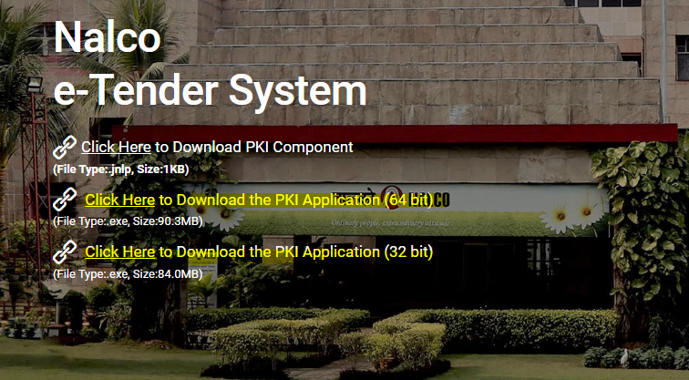
- To install the PKI application the process suggested as per the attached file should be followed. Ensure to get admin access to your own user id for installation process.
- In case the issue persists, following process should be followed.
- Exit the PKI component form the task bar as given in the screen shot below.
- Run the batch file (run_64.bat\run_32).bat as per your system configuration at folder C:\Program Files\nCodePKIComponent.
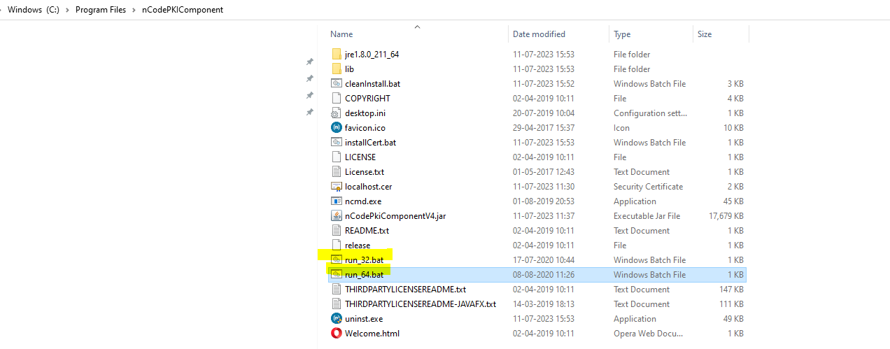
- Now try login to the Nalco eTender portal using the credential provided.

